Jal Rekha
User Manual




M.P. STATE ELECTRONICS DEVELOPMENT CORPORATION LTD.
State IT Centre, 47-A, Arera Hills, Bhopal-462011 (M.P.)
www.mpsedc.mp.gov.in
Table of Contents
Module…………… Mobile Application user …………….. 2
Downloading the app: 2
Device Registration Screen 3
Login Screen 4
Home Screen 5
Register Mobile 6
Sync Data 6
Mapping Asset 7
Module…………………… PIU …………………… 9
PIU User Login 9
User Management 11
Activate/ Deactivate Users 11
Pending For Approval 13
Assign Work 15
Data Visualization 16
View Mapped Asset 16
View Asset on Map 18

Module…………… Mobile Application user ……………..

Downloading the app:
To use the Jal Rekha Mobile app, first, the User needs to download the APK.
- Download and install the Jal Rekha app on your device.
- Open the Jal Rekha mobile app.



You are ready to go! Just follow the simple steps.
Note – Must have space in Mobile device approx. 1 or 2 GB.

Device Registration Screen
- After launching application, User should be able to register in the mobile application on the basis of mobile no. During registration user should input the following data.
  - Mobile Number
    - Send OTP
  - District
  - Designation
  - Full Name
  - Email Id
  - Password
  - Re-Enter Password
  - Gender
- Once User will enter above details and tap on Register Mobile Button then the system will register the user, save the enter details in the database and redirect to the Home Screen.
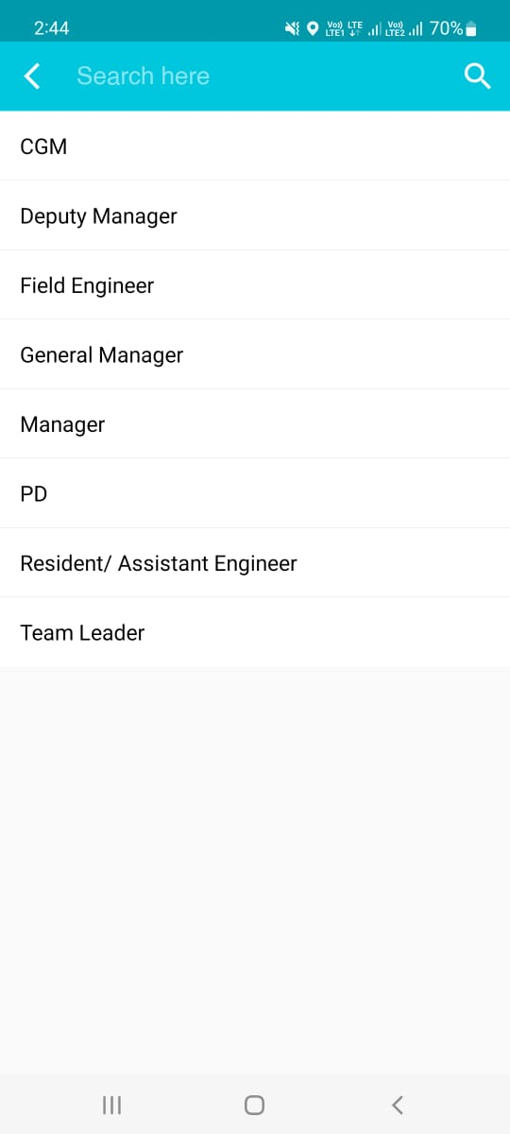

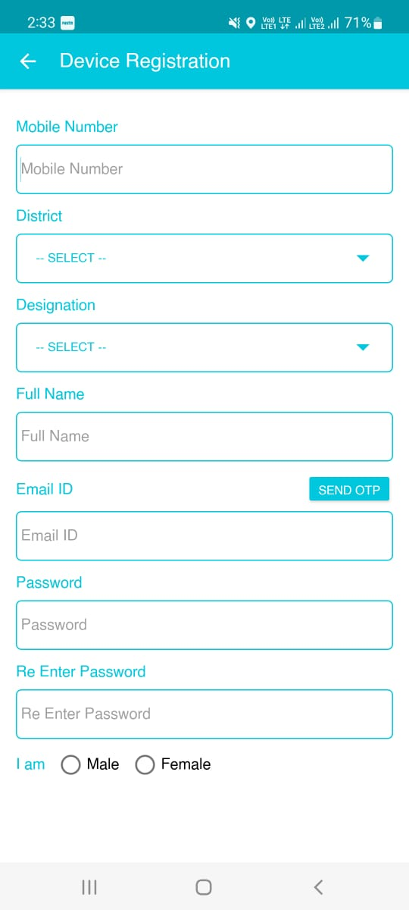

- If user already registered in the mobile app, Concerned PIU approved the Mobile user and assign the Scheme’s.

Login Screen
- If User already registered with device and mobile number then user will enter following details
- Registered Mobile Number
- Password
- Next button
- Once User will enter above details and tap on Next Button then the system will redirect to the Home Screen.
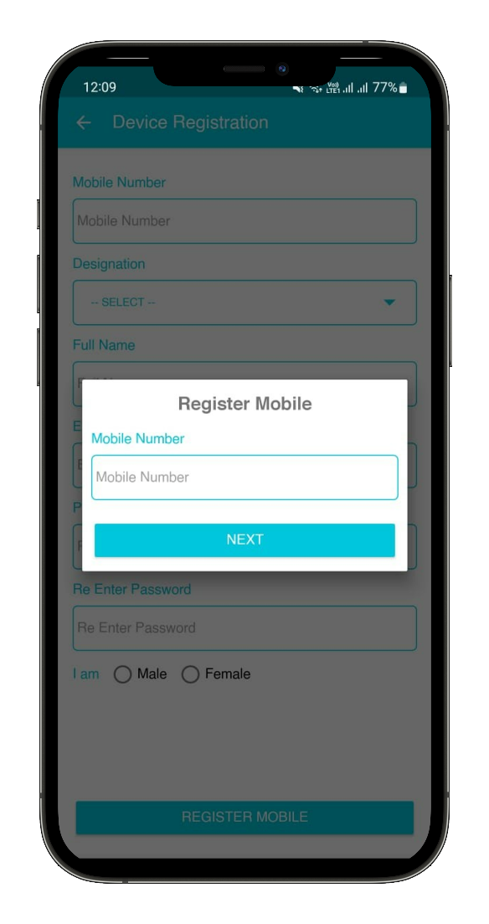
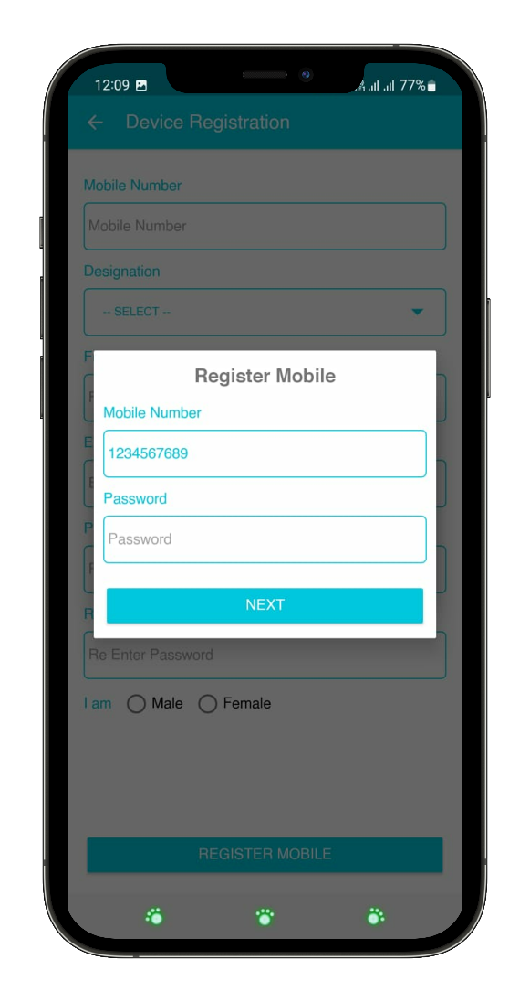

Home Screen
- After successfully registration in the Mobile app, by default user can land on home screen where user can follow section-
- Register Mobile
- Sync Data
- Mapping Asset
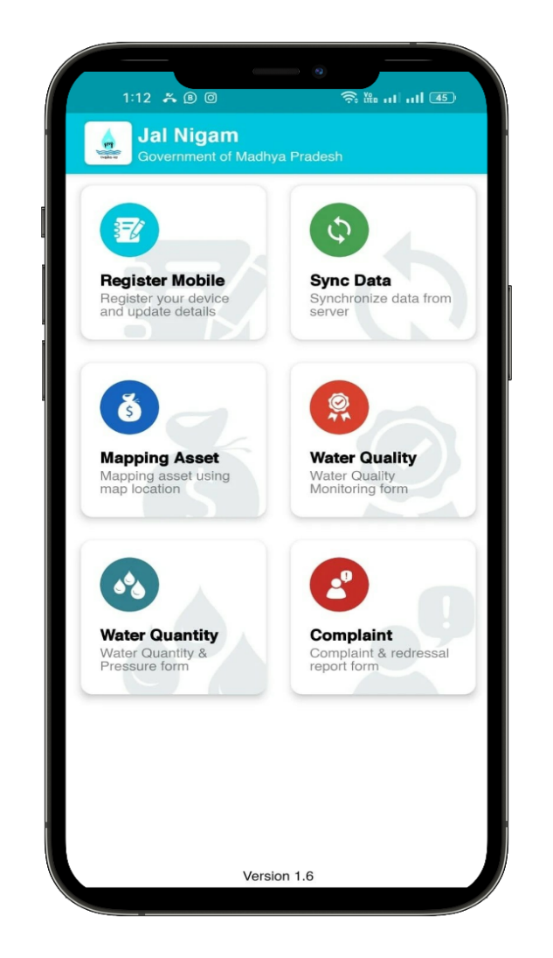
- Once user will tap on any above options then the system will redirect user to the respective screen

Register Mobile
- User can view their profile details and update it if required. User can view following field-
- Designation
- Full Name
- Mobile Number
- Email Id
- Gender
- Request Update Button
- Once User will enter above details and tap on Request Update Button then the system will update the user details and update details in the database.
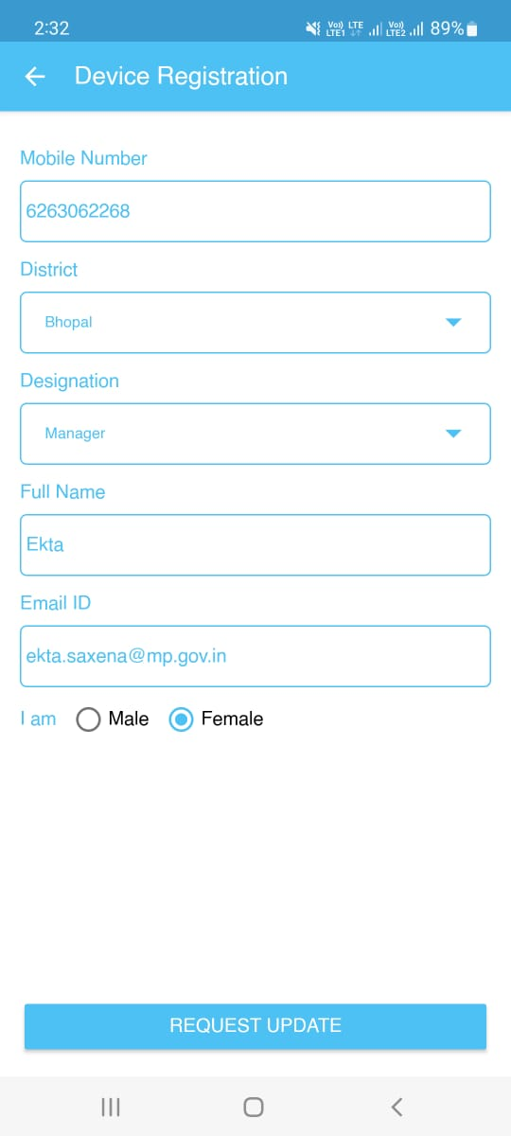


Sync Data
- User need to tab on Sync data section then the system will sync assign component or task and update so user can fill data of assigned schemes.
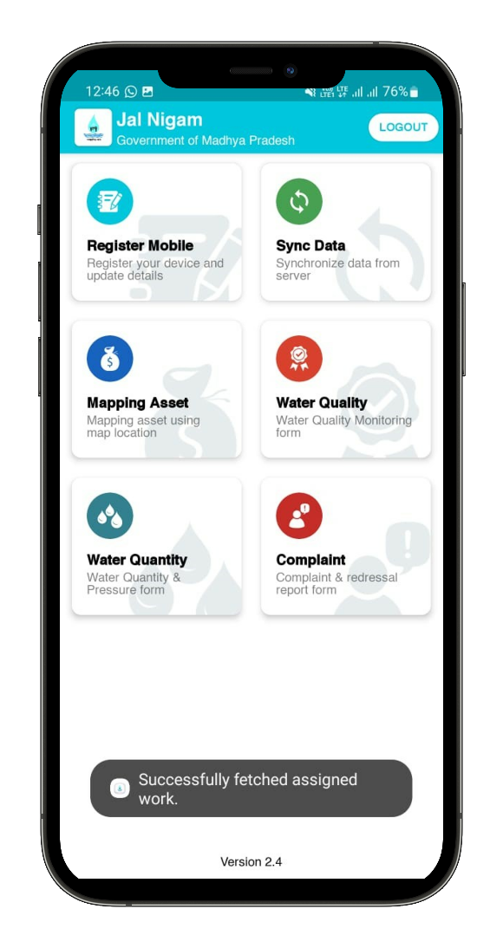
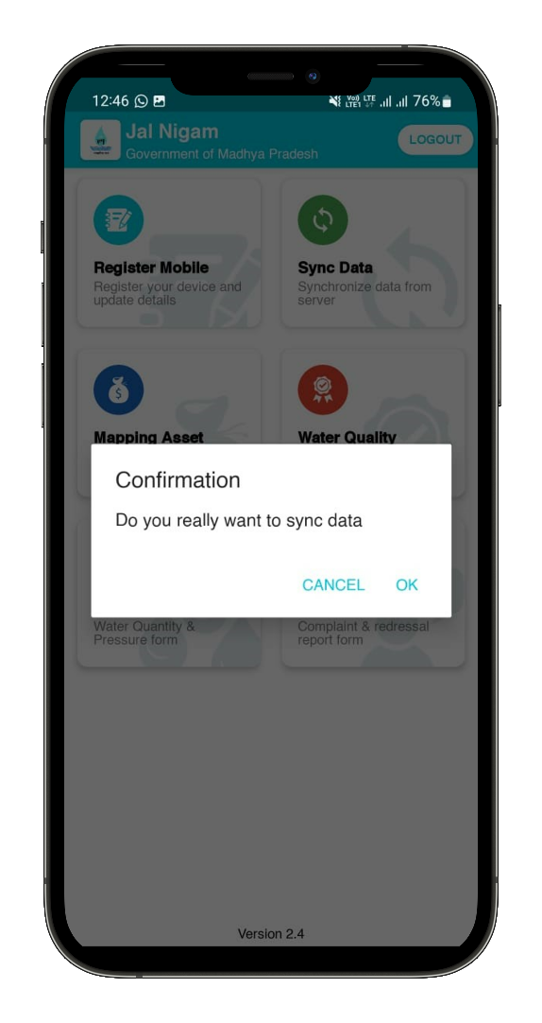

Mapping Asset
- Successful Sync Data, User can fill Asset data by selecting following field
- Scheme (Display assigned schemes– Non Editable)
- Select ESR Location
- Component (Display assigned component – Non Editable)
  - BPT
  - Intake Well
  - MBR
  - OHT
  - PMBR
  - Valve
  - WTP
- Capture or Upload Photo
- Enter Review
- Save button
- Once user will enter any above field and tab on save button then the system will redirect to the Asset list screen.
- User can view list of assets that are added by them with Upload.
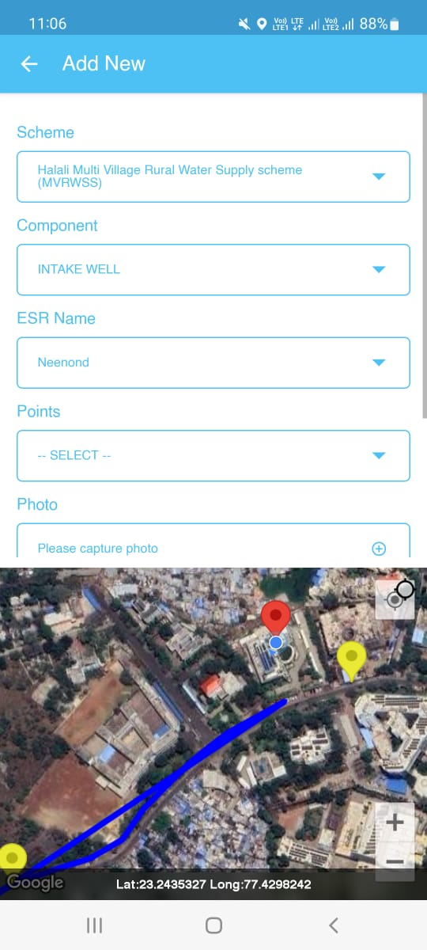

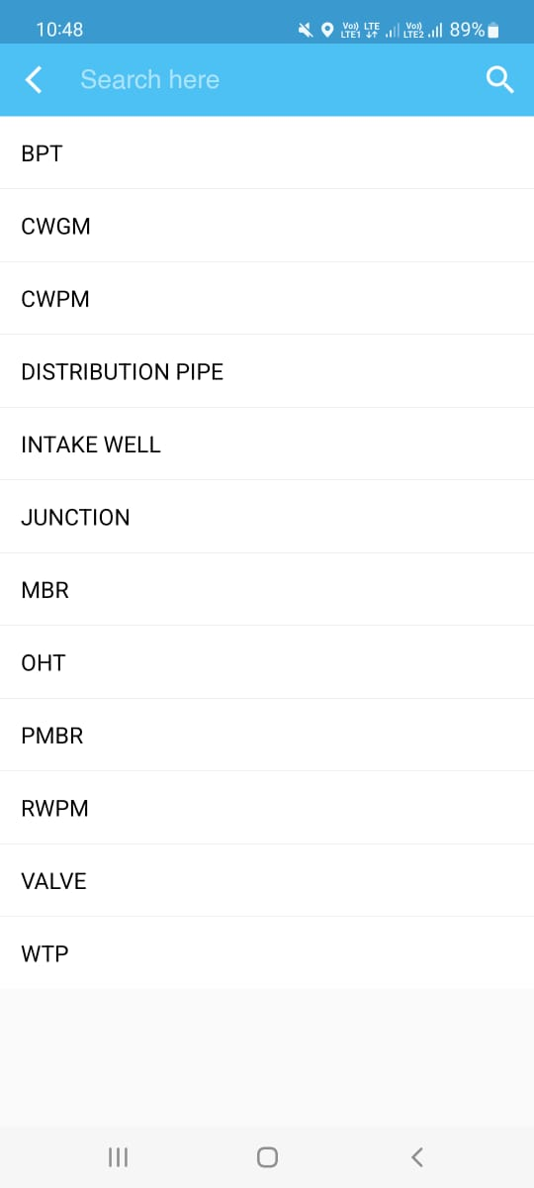

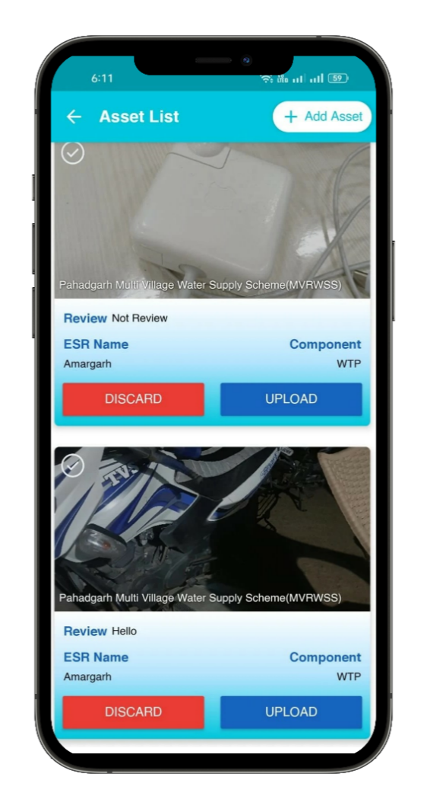
- Once user will tap on upload button then the system will submit the data to the concern Authority, PIU and Admin.

Mapping Asset- Junction:
- If user select the “Junction” component from a dropdown menu

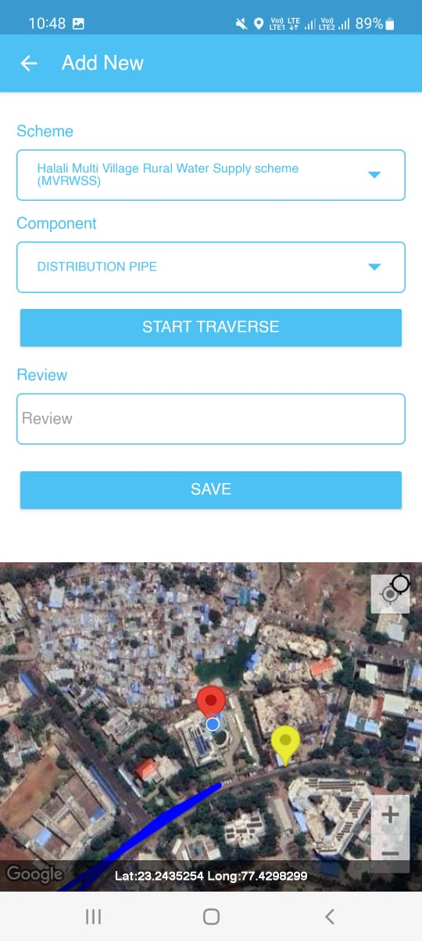



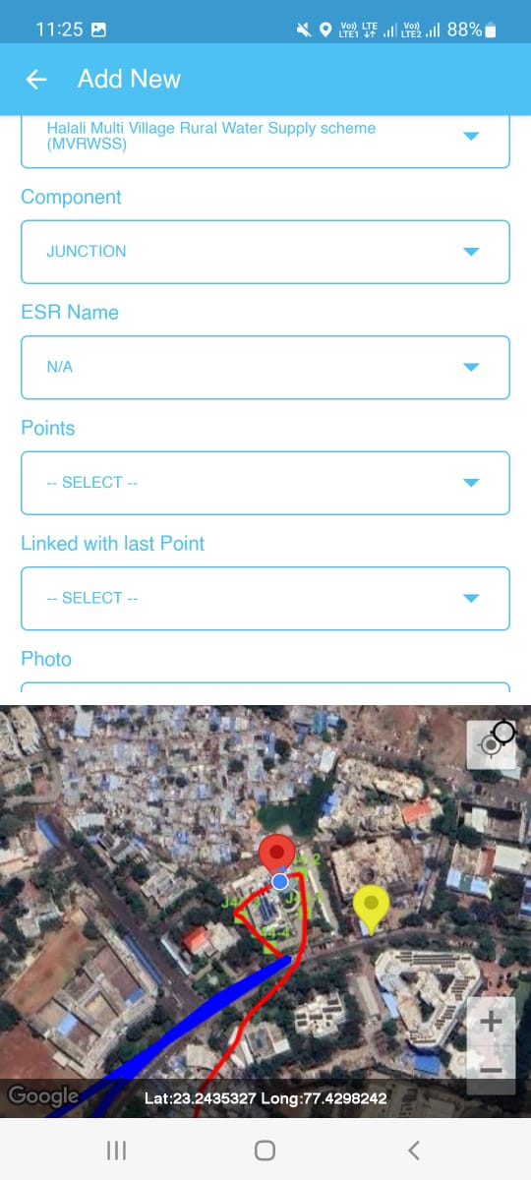

Traverse in Mapping Asset
- The Traverse functionality enables users to move through the data and explore different attributes (CWGM, CWPM, Distribution Pipe, Junction and RWPM, or spatial locations. The scheme and ESR name fields are pre-filled and assigned by the PIU. Users can select a component from a dropdown menu, click a photo, enter a review, and save the location. The app can access the user's location after registration.





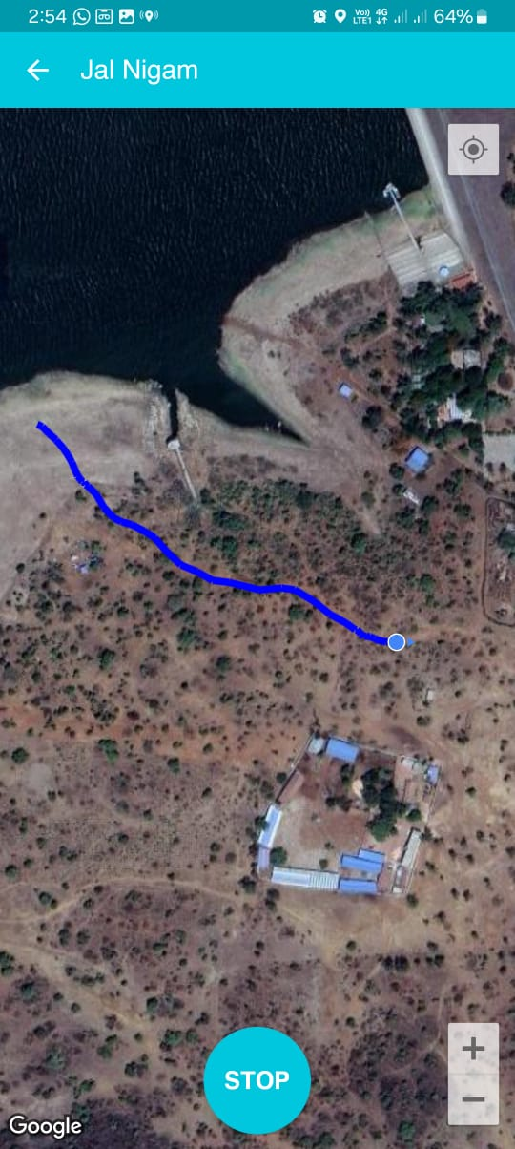



Module…………………… PIU User ……………………

PIU User Login
The web portal can be opened using the URL given below
https://geoportal.mp.gov.in/MPPHE
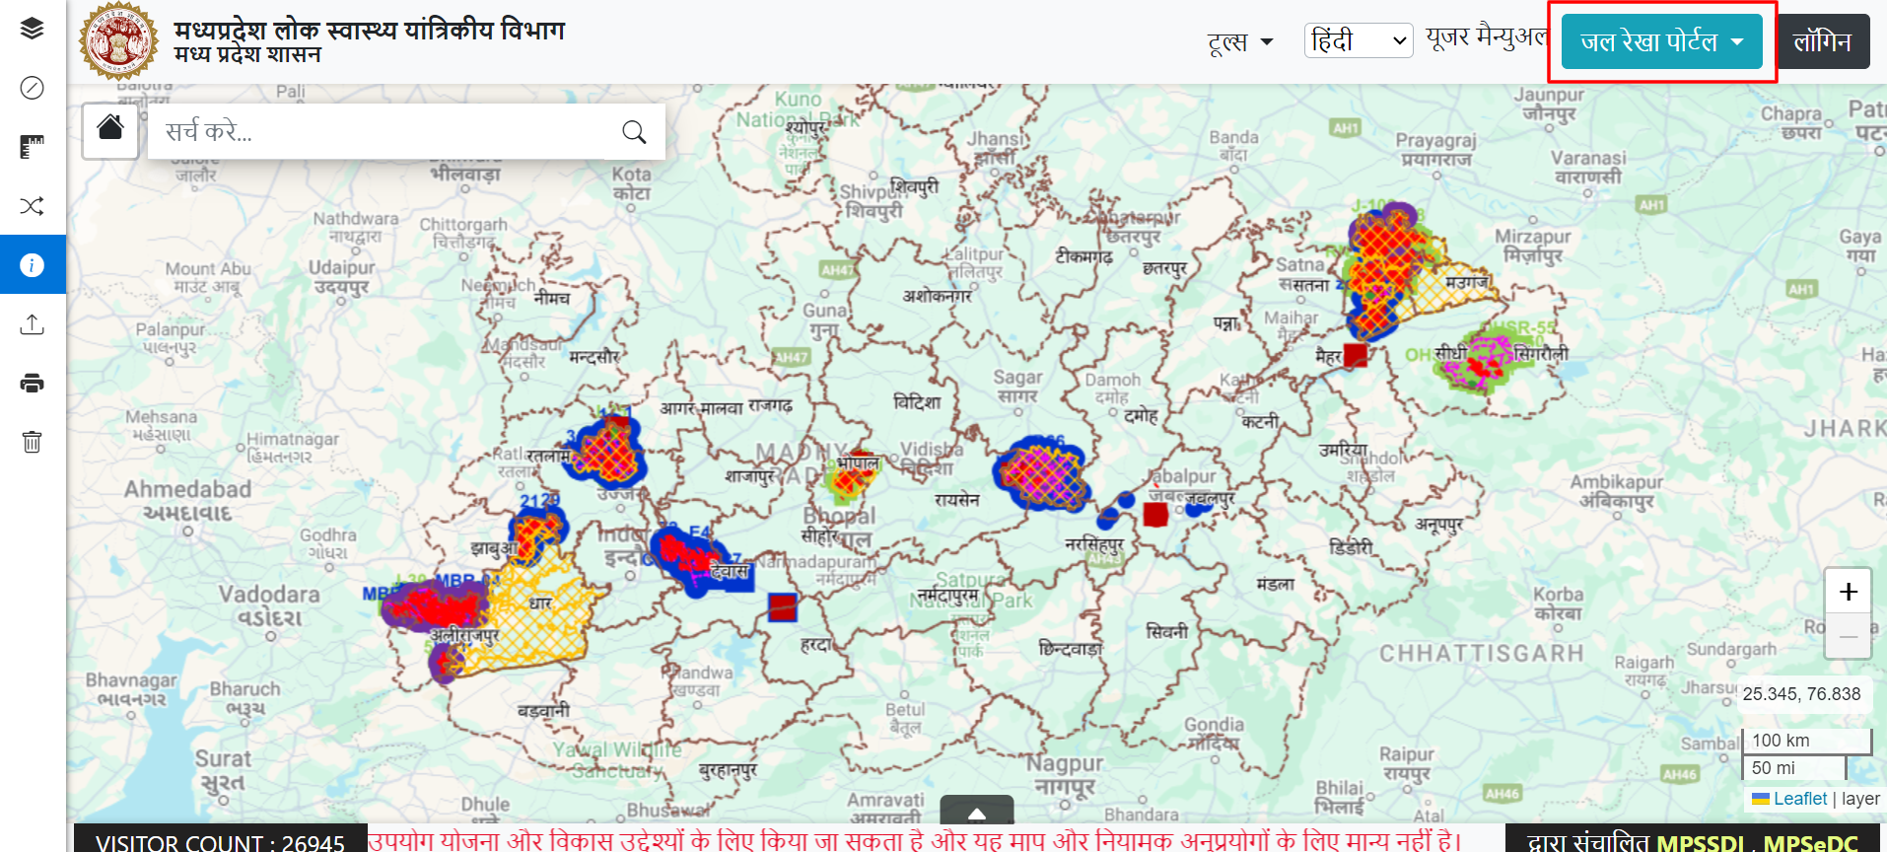

- PIU user can access the web application by using the authorized login credentials.
- Click on the Login button
- Enter the desired details on the login page.
- Enter Username.
- Enter Password.
- Click on the Login button.

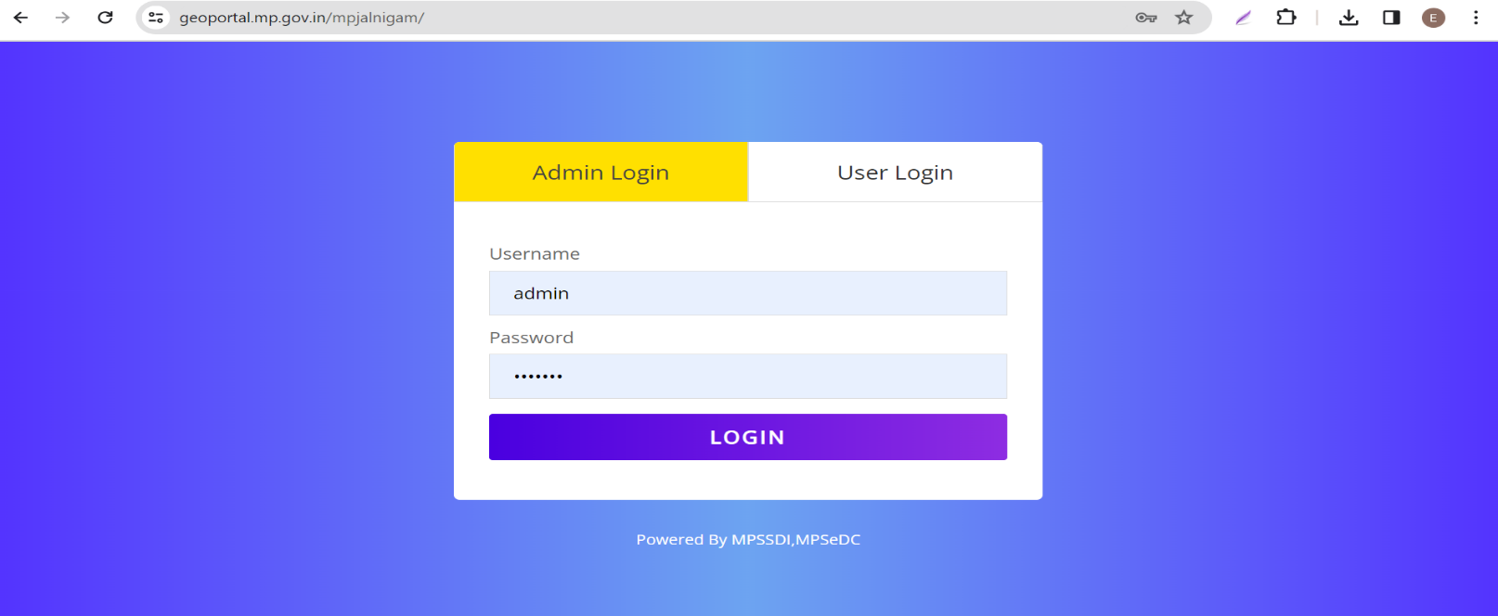

- After successfully login, PIU user will land on User Management page. User can view following menu in header
- User Management
- Data Visualization
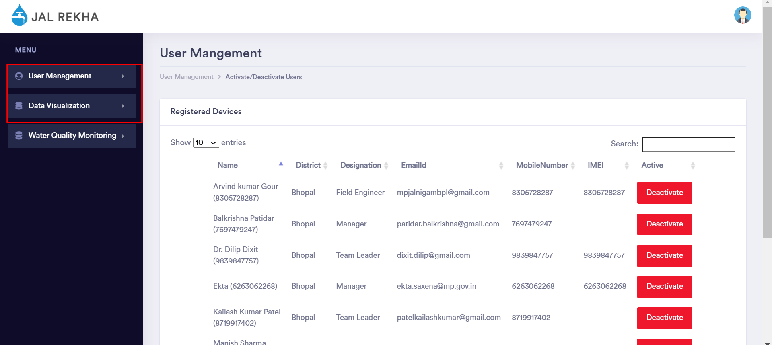

User Management
- PIU user will click on user Management then PIU user can view following options
- Activate/ Deactivate Users
- Pending For Approval
- Assign Work
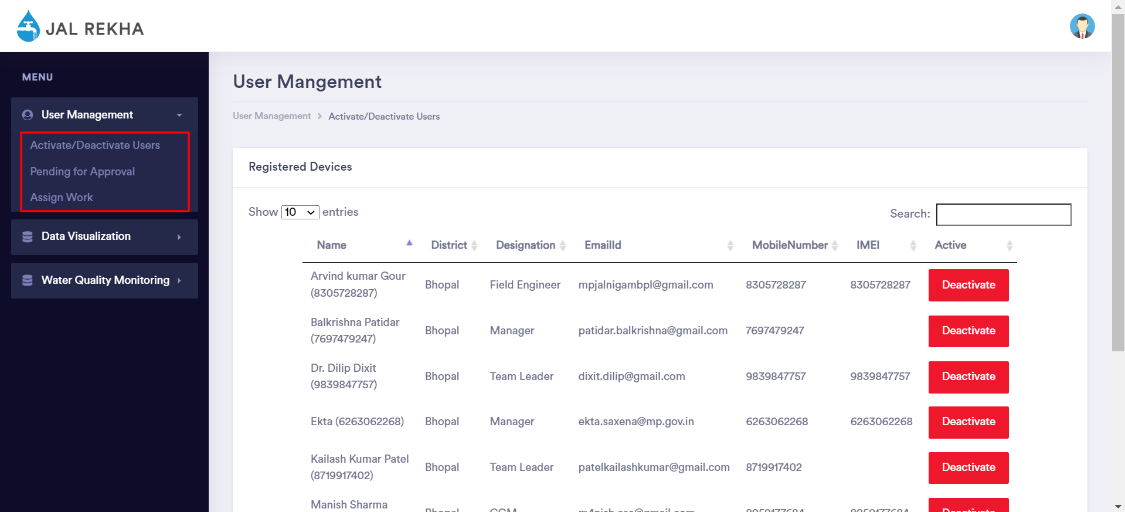
- Once PIU user will click on any above options then the system will redirect user to the respective page

Activate/ Deactivate Users
- If PIU user will select Activate/ Deactivate Users then the system will redirect user to the respective page.
- PIU user can view list of registered mobile user that are self-registered into Mobile app, PIU user can view following details
- Name
- Designation
- Email Id
- Mobile Number
- IMEI
- Status of User
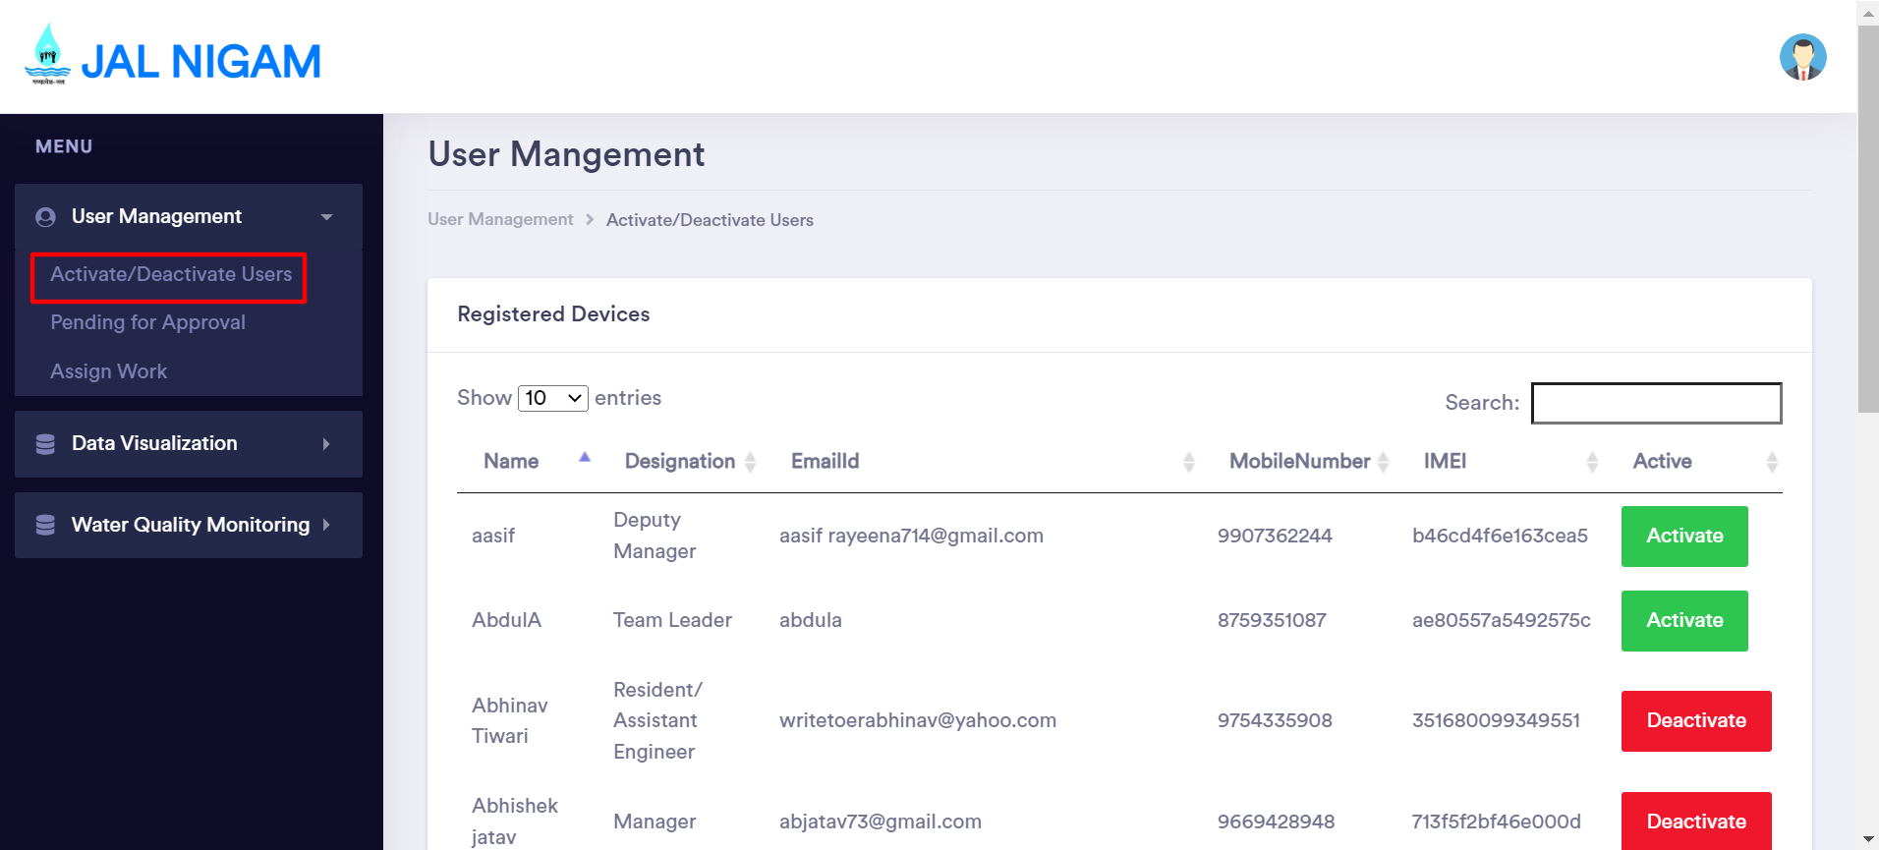

- PIU user will receive Mobile user request to Activate and Deactivate. PIU user have rights to Activate/Deactivate any user.

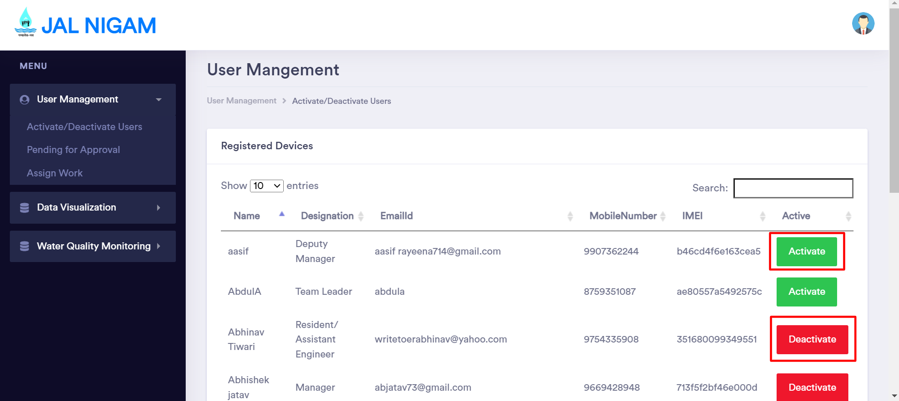

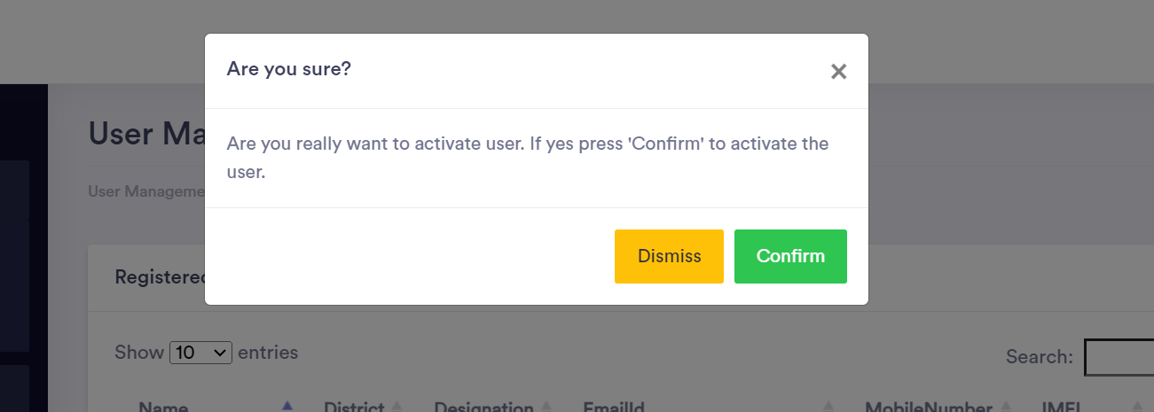
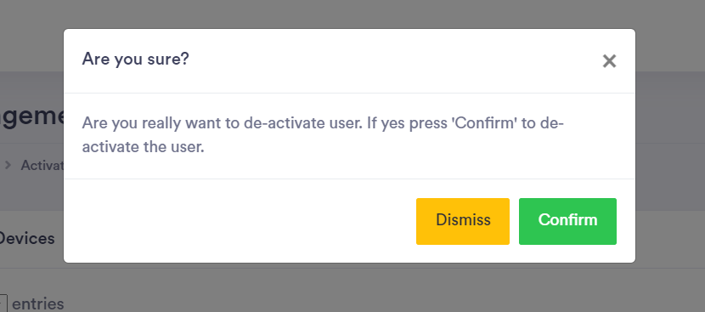

Pending For Approval
- PIU user can view list of registered mobile user that are pending for approval. PIU user can view following details
- Name
- Designation
- Email Id
- Mobile Number
- IMEI
- Action
- Approve/ Delete link
- PIU user will approve or Delete any user that are available in the list.
- PIU user can search any user by enter keyword in the search box.
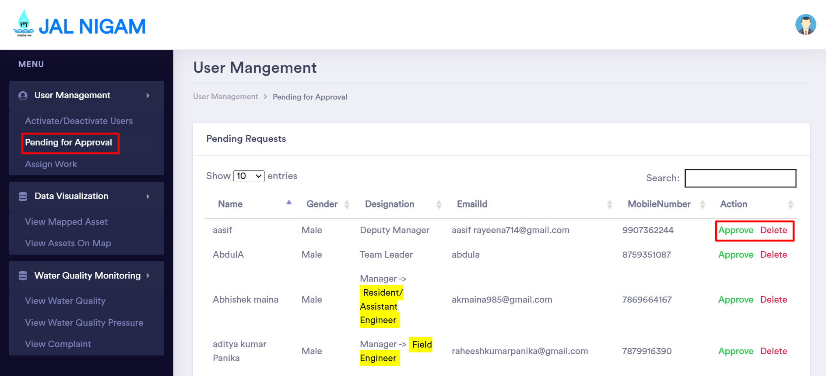
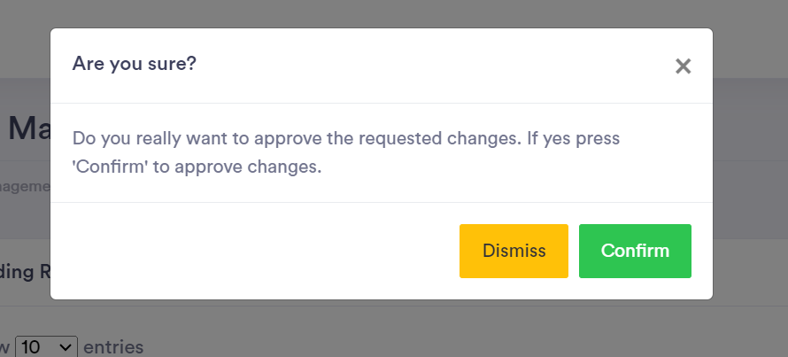
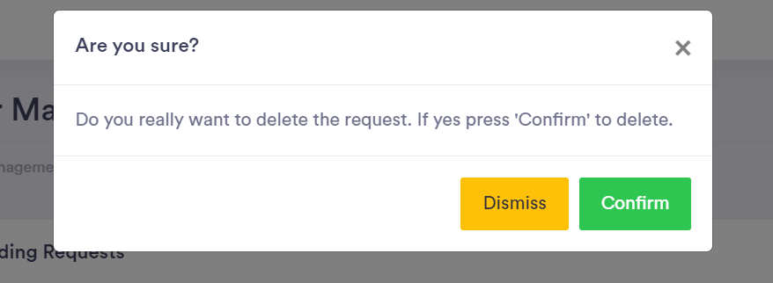

Assign Work
- PIU User will assign work for any user that are registered, PIU user will assign work by selecting following field
- Select User
- Select Scheme
- Select ESR Location
- Assign and Reset button
- Once PIU user will click on Assign button then the system will assign that selected scheme to the selected user.
- PIU user can view selected user work that already assign the work.
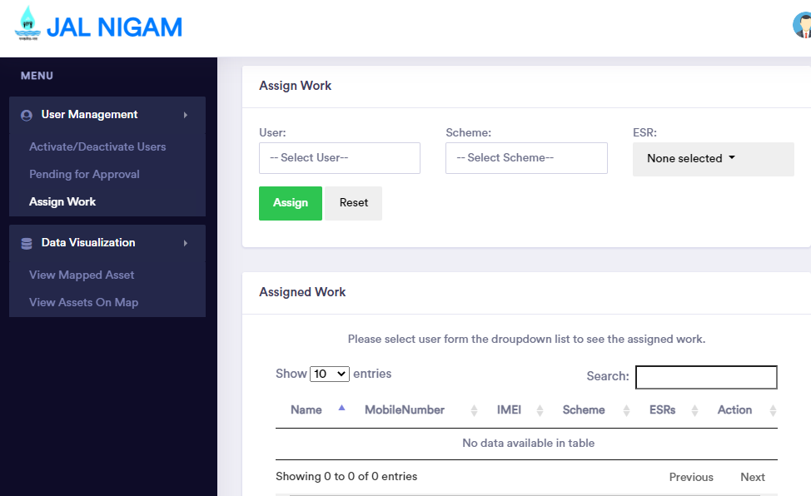

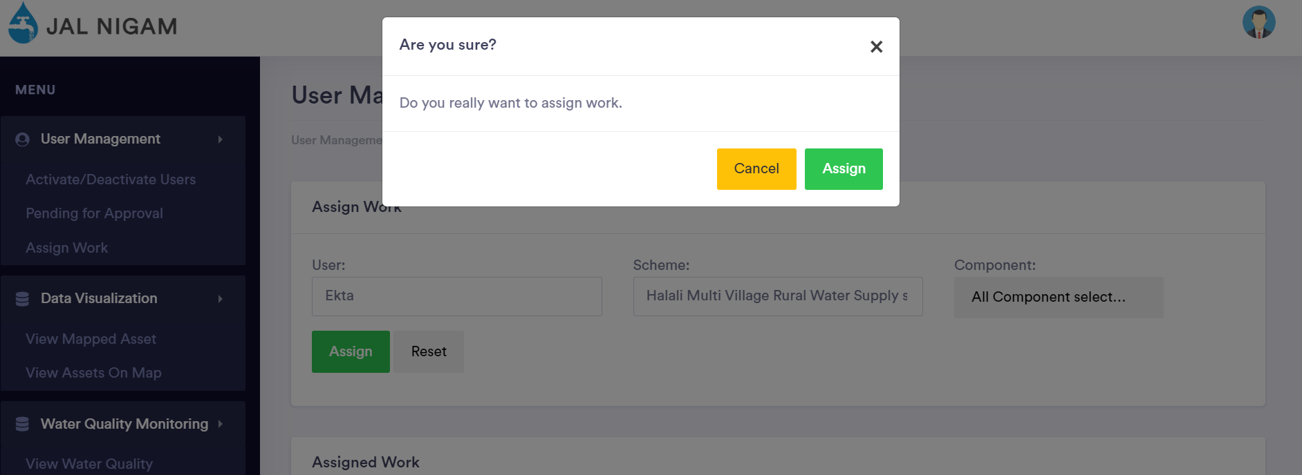

Data Visualization
- PIU user will click on Data Visualization then PIU user can view following options
- View Mapped Asset
- View Asset on Map
- Once PIU user will click on any above options then the system will redirect user to the respective page

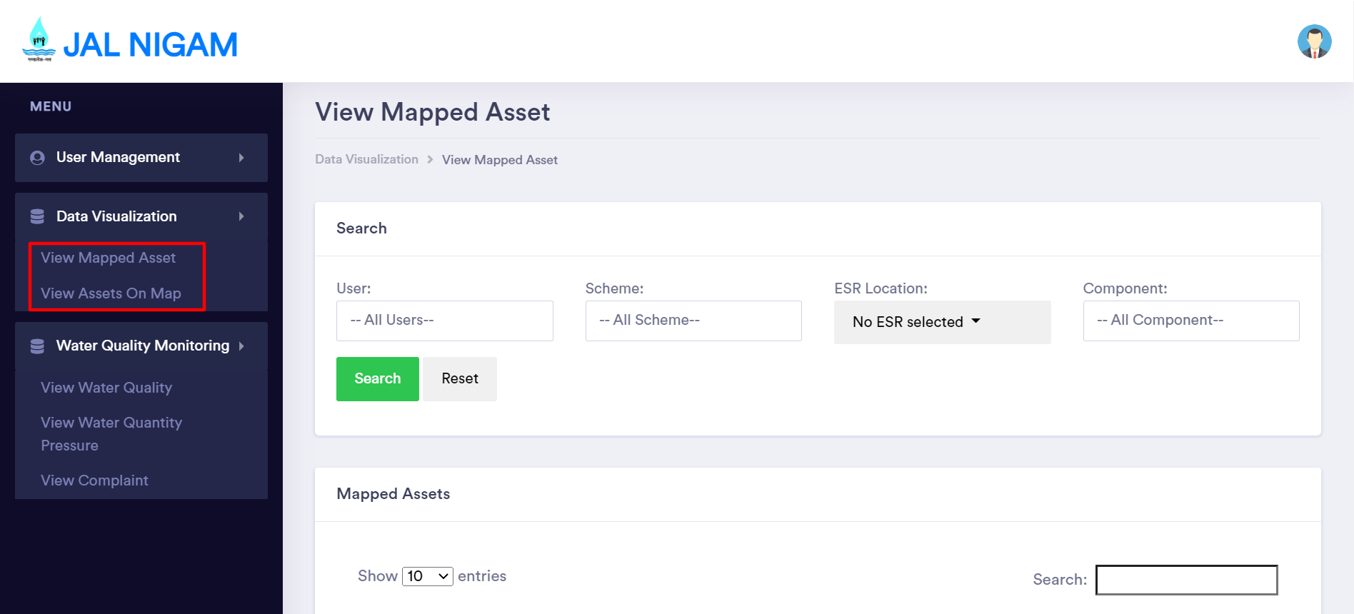

View Mapped Asset
- If Admin user will select view Mapped Asset then the system will redirect user to the respective page.
- PIU user can search data by selecting any field in below available field
- Select User
- Select Scheme
- Select ESR Location
- Select Component
- Search and Reset button
- Once PIU user will select any above field and click on search button then the system will display all the list of Asset data of selected user that selected user added.
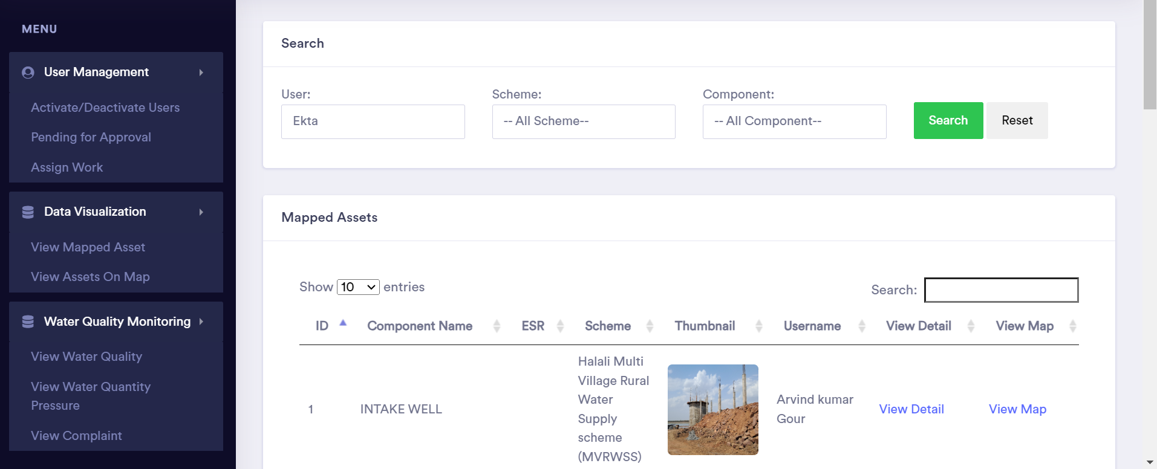

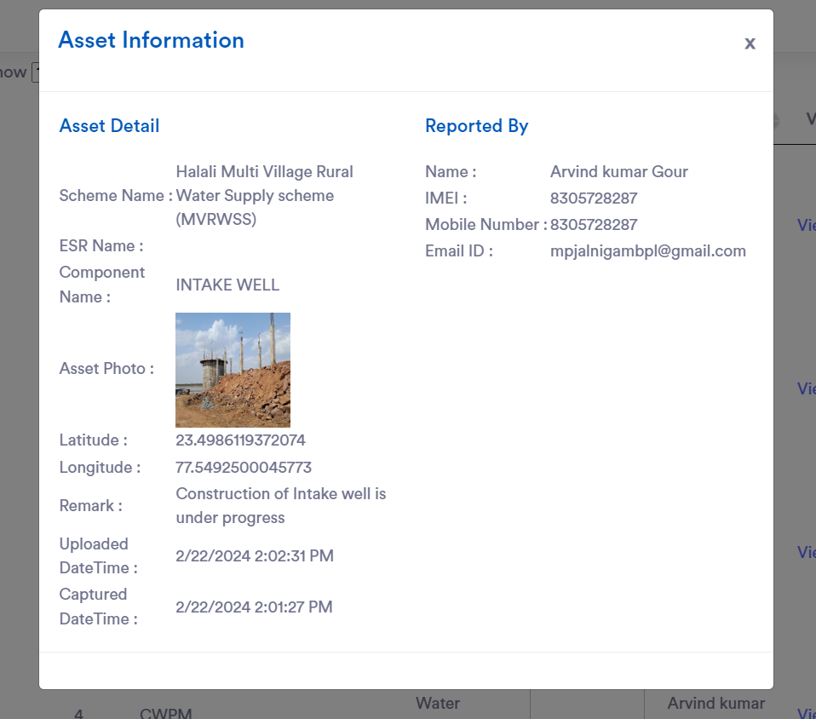

View Asset on Map
- If PIU user will select view Asset on map then the system will redirect user to the respective page.
- PIU user can search data by selecting any field in below available field
- Select User
- Select Scheme
- Select ESR Location
- Select Component
- Search and Reset button
- Once PIU user will select any above field and click on search button then the system will display all the list of Asset data of selected user on map that selected user added by Mobile app.

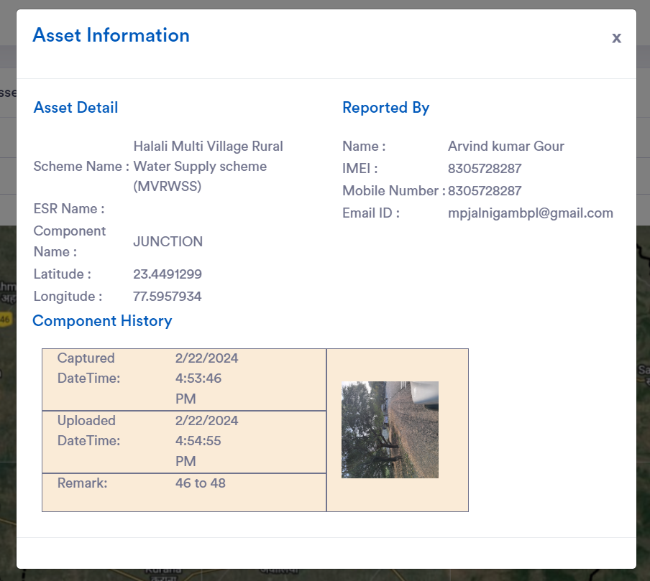
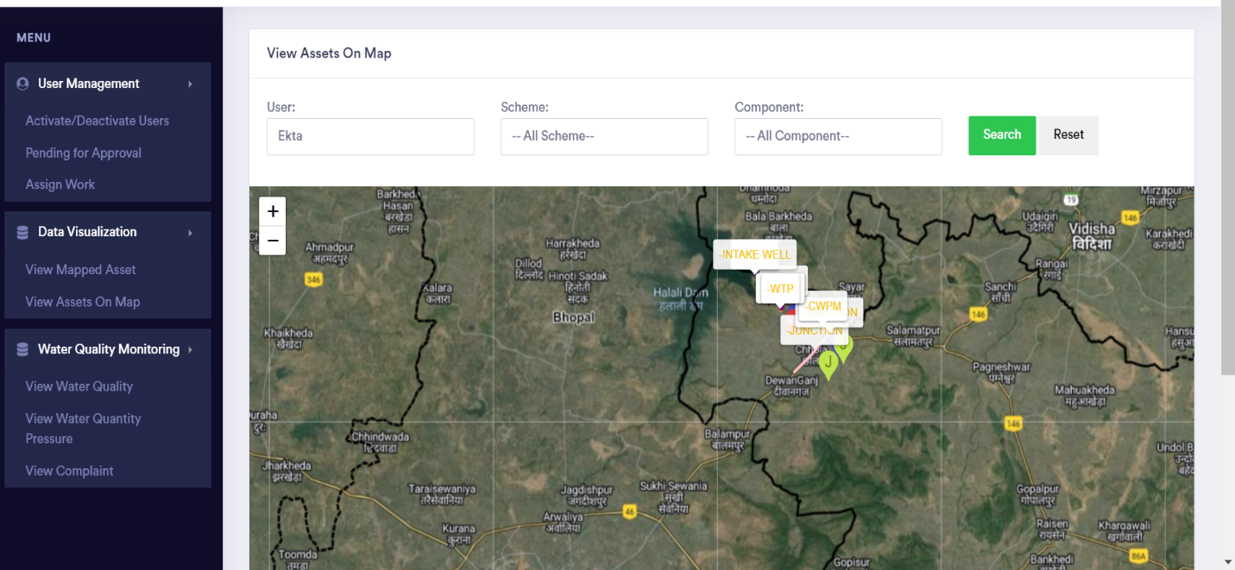

Thank you

